|  |  |  |  |  |  |
| --- | --- | --- | --- | --- | --- |
| Date | December 6, 2022 | | | Tester Name | Syed Shahabuddin |
| Environment | Penfax - Test | | | Login used |  |
| Operating System | Windows | Version: | Update: | | |
| Software Used | Edge | Version: | Update: | | |
| Select Software | Version: | Update: | | |
| Release version | 22.4.1 | | | | |
| Title | E26.04 | | | | |
| Test Type | Regression | | | | |
| Test Scenario | Receiving scheduled monthly payments with a withdrawal type of fixed amount, pro-rated depletion method and moving to the next PEPP step. | | | | |
|  |  | | | | |
| Expected Results | Confirming that ITA minimum amount for the year doesn’t change, and that the minimum age factor is correct when compared to VPB PEPP talk chart of minimum age factors, even after the birthdate change.  Confirm that the PEPP rollover doesn’t interfere with the scheduled payments & processes correctly. That the number of units do not change between the two funds.  The DAI changes as well as the interfund processes. Letter will not generate for pro-rated. | | | | |
| Pass/Fail | Pass | | | JIRA# | N/A |

I found a VPB member that is active.

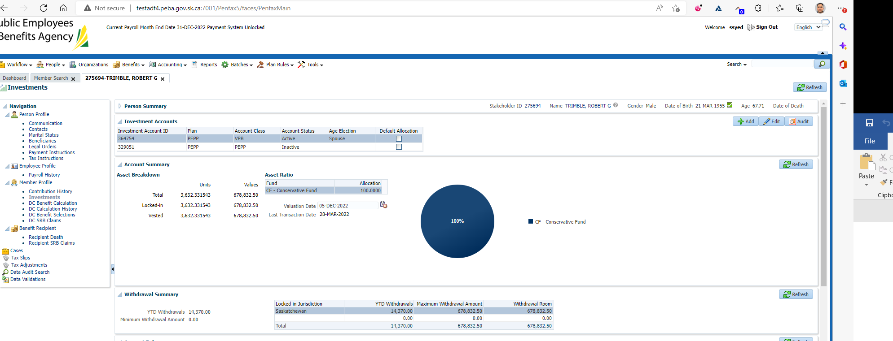

SID: 275694

Processed an interfund transfer to steps & MM. I added a scheduled payment to fit the criteria of the test.

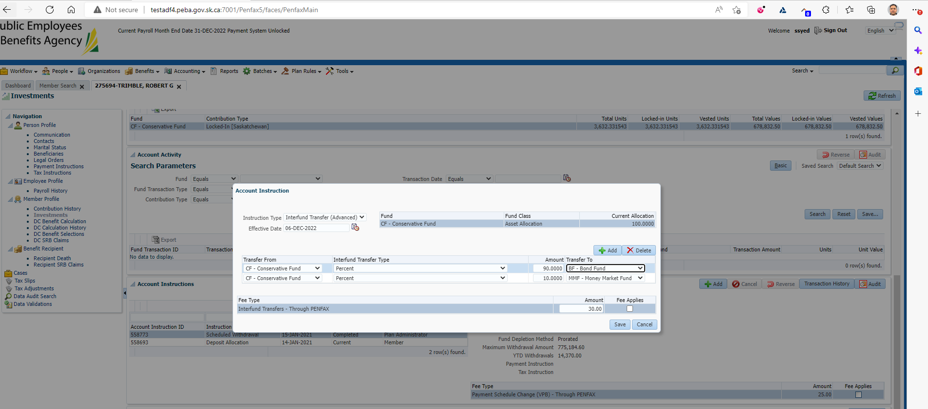

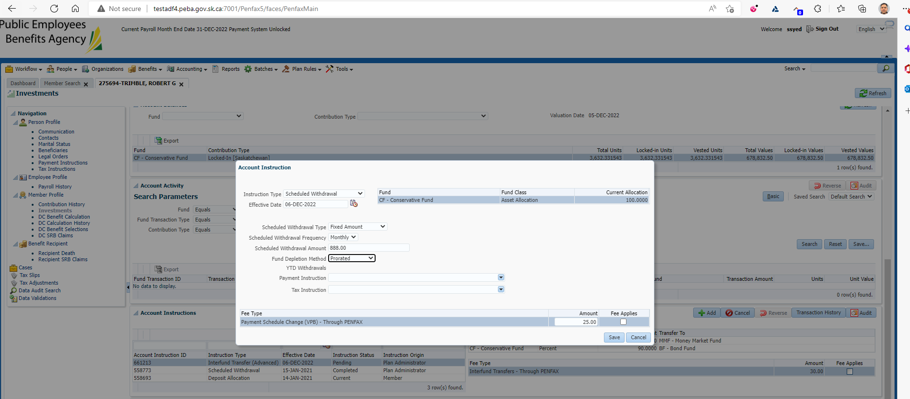

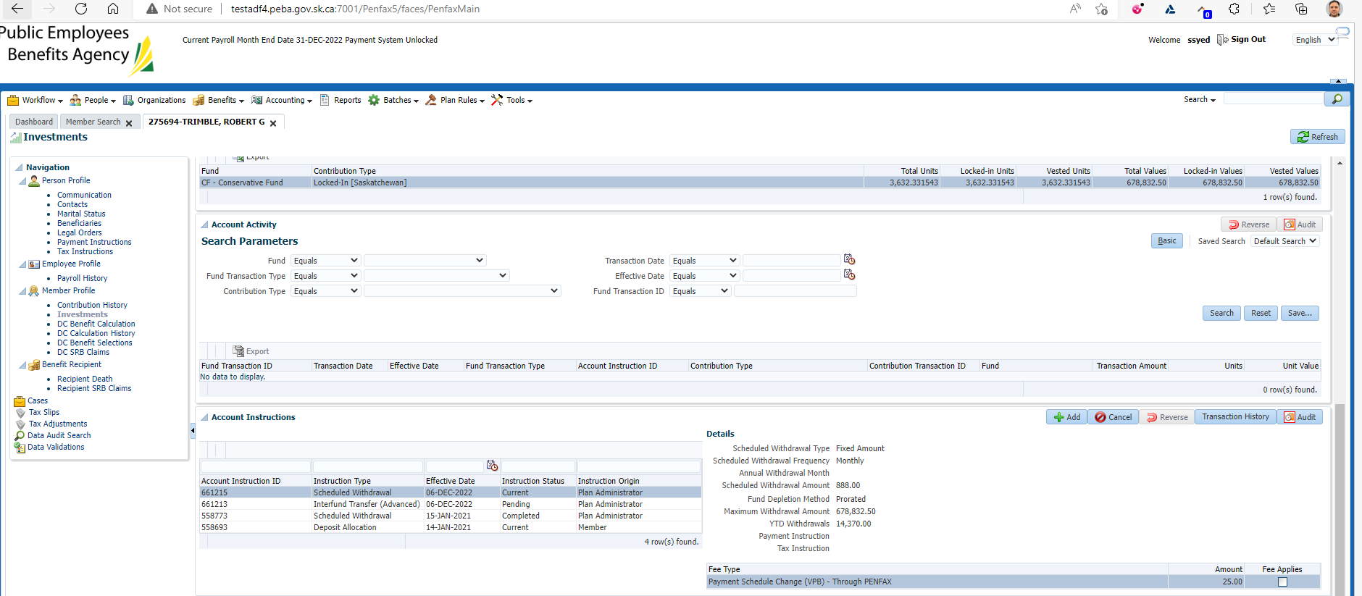

Update birthdate to 2 days from now.

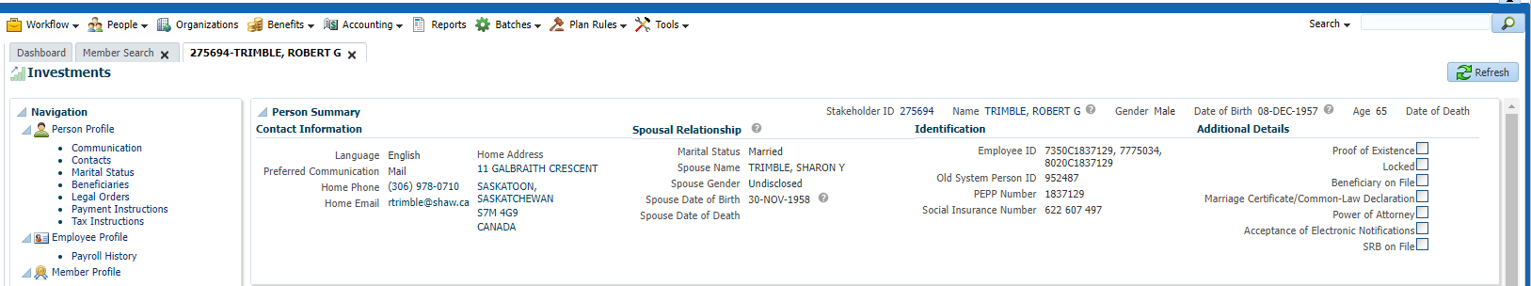

Wait for PIT & Life cycle batch.

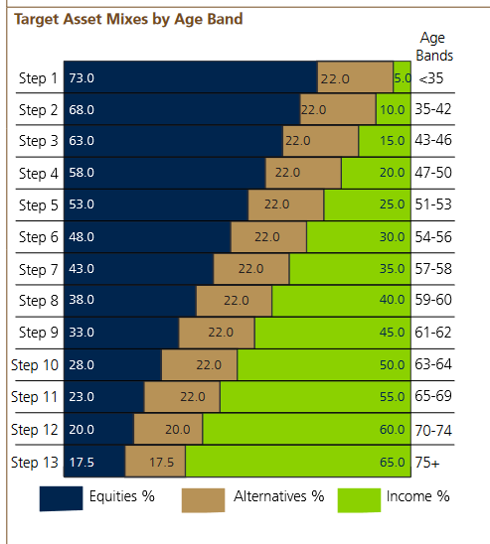

Day 2: Original interfund went through & Lifecycle batch interfund is pending to move to step 11:

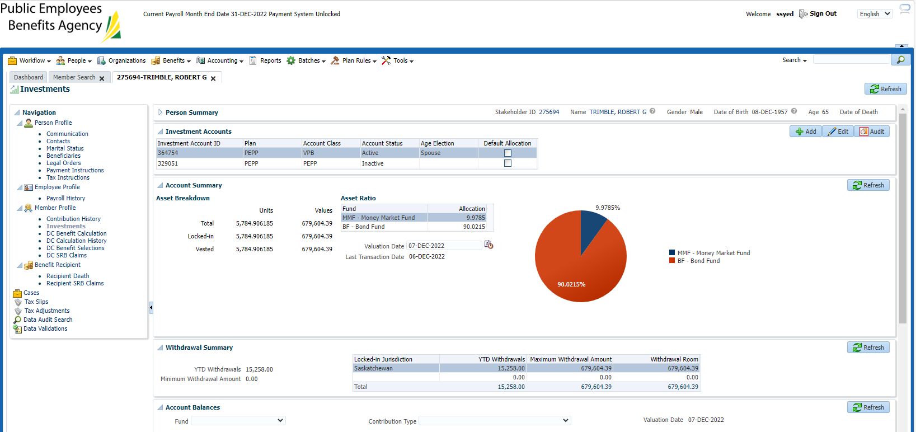

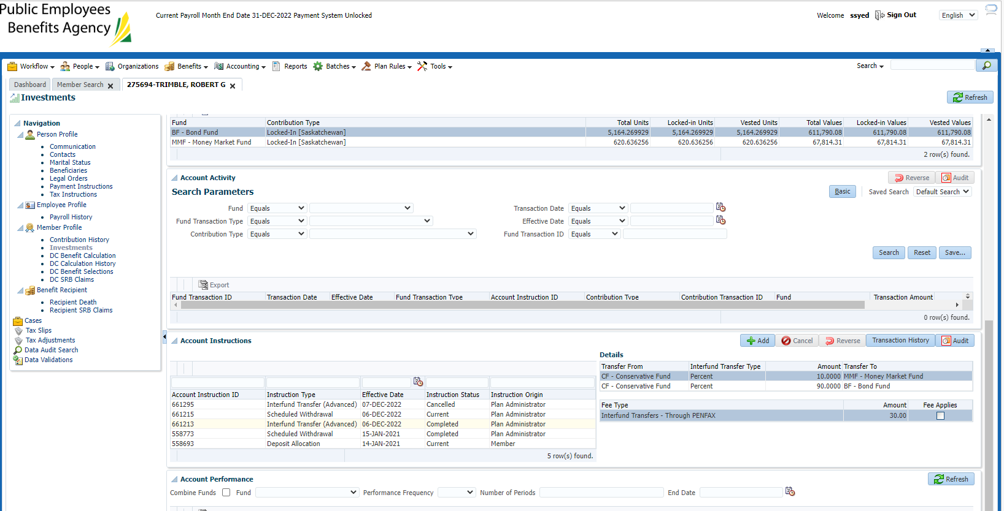

Day 3: Confirm interfund for lifecycle went through & no letter

Yesterday, changed from step 11 to step 10 due to birthdate change

Today, change from step 10 back to step 11 is pending:

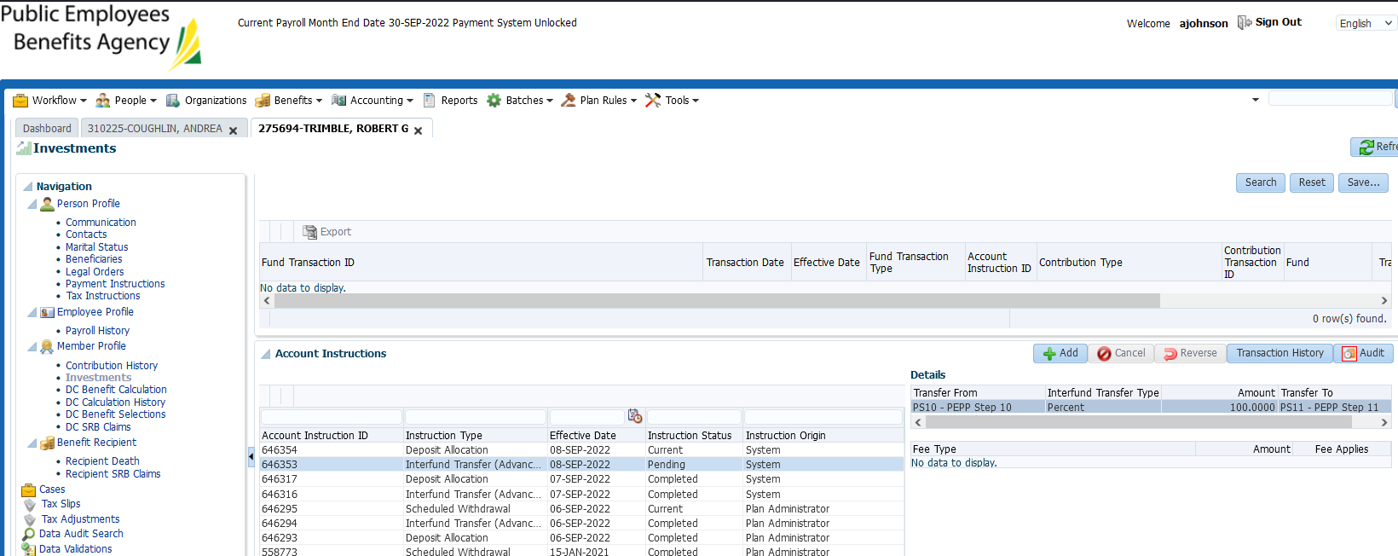

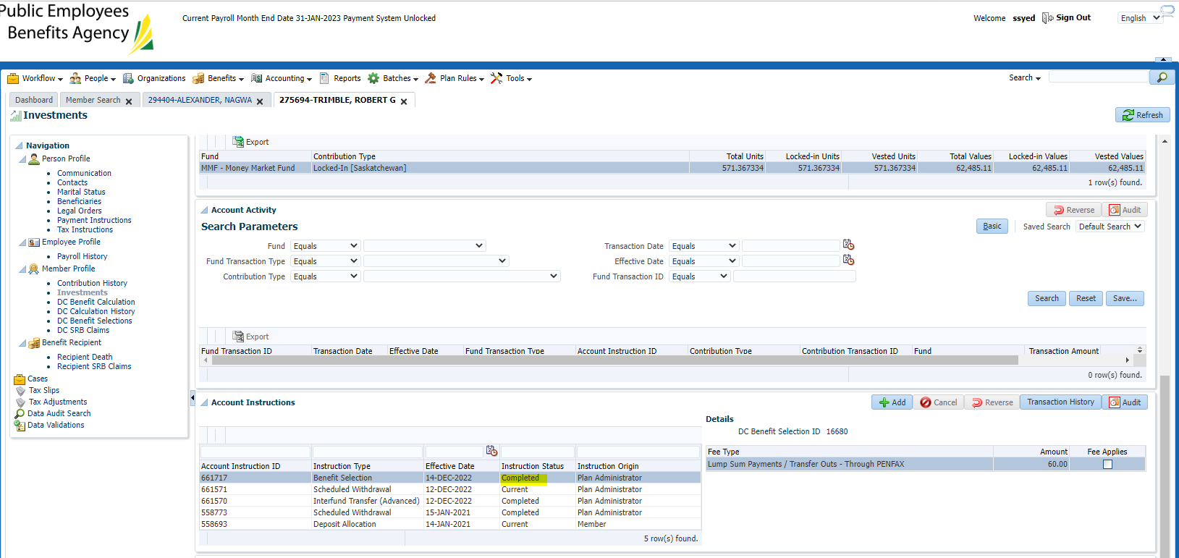

Day 4 (Dec 15th):

Confirmed interfund is completed & no letter.

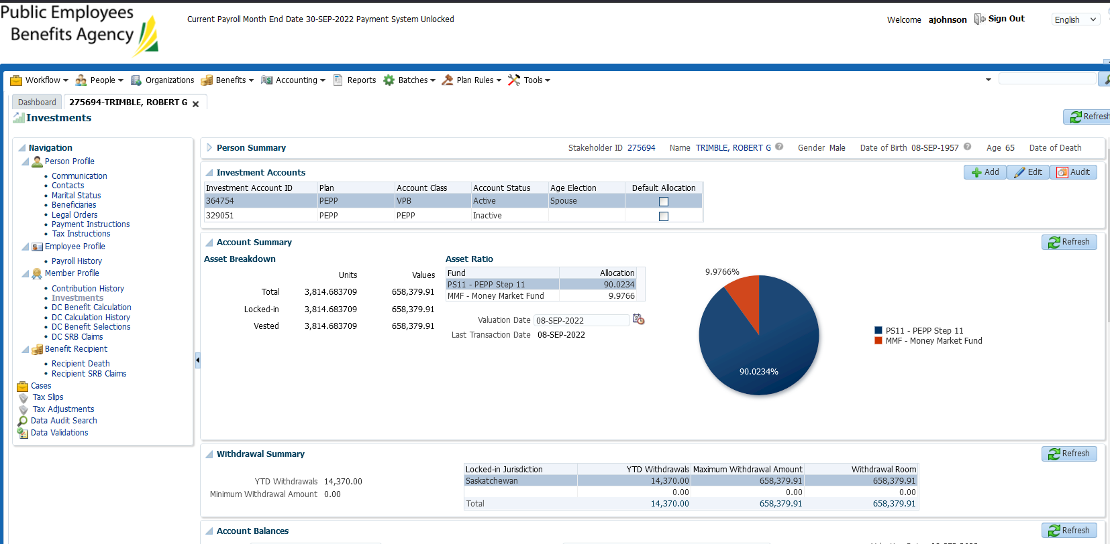

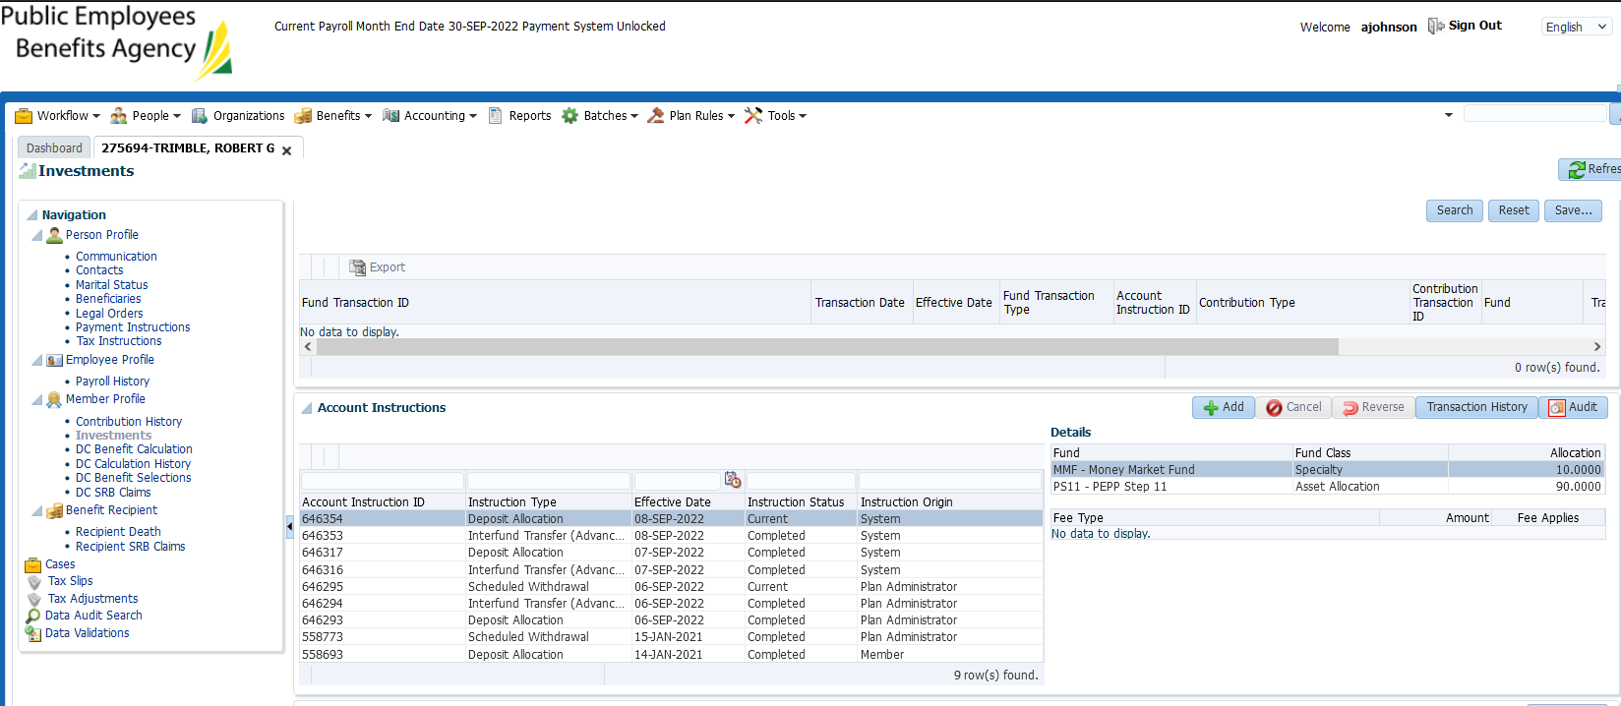

No letters on Dec 14th

